Attachment 2: Required Document Check List

Applicant Name:

You must return this completed check list with your application package. Complete this check list to confirm the items in your application. Place a check mark or “” next to each item that you are submitting. You must return all required attachments for OSHPD to consider your application responsive.

Document Document Name/Description

_ Attachment 2 Required Document Check List

_ Attachment 3 Peer Personnel Training and Placement Application Form

_ Attachment 4 Application/Applicant Certification Sheet

_ Attachment 5 Professional Reference

_ Attachment 6 Participation Verification Form

_ Attachment 7 Payee Data Record (STD 204)

_ Attachment 8 Contractor Certification Clauses Form

Attachment 3: Peer Personnel Training and Placement Application Form

Complete all sections of this application form. (Please use Arial font no smaller than size 10)

- Executive Summary. Provide an overview of the services that you propose to provide as delineated in Section A. Background and Mission and describe your ability to provide such services. (Maximum 1000 words)

- Program Description. Provide a detailed description of the proposed program, including how it will address all the components detailed in the Grant Guide under Section A. Background and Mission. (Maximum 1000 words)
Applicants must include information on how your program incorporates the following elements:

      - Lived Experience: Describe how you developed the proposed Peer Personnel Training and Placement Program and the extent to which individuals with lived experience participated in its development. (Maximum 1000 words)

      - PMHS Peer Personnel Needs: Describe the Peer Personnel needs of the PMHS employer partners and how the proposed program will address those needs. (Maximum 1000 words)

      - Continued Engagement: Describe how the program will ensure the continued engagement and coordination with county(ies), CBOs, and educational institutions and/or training entities listed as partners in the application. (Maximum 1000 words)

      - Strategies: Describe how the applicant will ensure focus on innovative, evidence-based, emerging, and/or community-identified strategies to achieve the goal of training and placing peer personnel in the PMHS. (Maximum 1000 words)

      - MHSA Values and Priorities: Describe how all program activities are consistent with the following MHSA values and priorities. (Maximum 1000 words):

  - Community collaboration
  - Cultural competence
  - Client/family-driven mental health system
  - A wellness, recovery, and resilience focus
  - An integrated service experience for consumers and their families to
address the changing needs of the PMHS

C. Target Population. Indicate the number of individuals the program proposes to serve. OSHPD does not require a minimum number of participants. OSHPD will include this number in the grant agreement and, if awarded, use it to determine prorated payments across budget categories as outlined in the table under Budget Detail in Section I.

- Number of individuals served:

# _____

- Demographics of population served: Provide the number of individuals the applicant proposes serving with this program, and the demographic make-up of the target population, including those from underserved, unserved, and/or inappropriately served racial and ethnic communities. (Maximum 250 words)

D. Participating Organizations. List all the organizations within the PMHS (this includes counties and CBOs), describe program activities, and provide a summary of peer personnel needs identified in Attachment 6: Participation Verification Form.

Organization Name | Organization Type (county, CBO) | County | Description of Program Activities Partner Organization Will Support (i.e., recruitment and outreach, career counseling, training, placement, and support). Description should be no more than six sentences per organization. | Summary of Peer Personnel Needs (for county and CBO) Identified in Attachment 6: Participation Verification Form

E. Program Components

- Recruitment and Outreach: Describe how the applicant will recruit individuals who are either currently employed or volunteering, or who are seeking employment or to volunteer in the PMHS as peer personnel and targets individuals with lived experience who can address the cultural and language needs of the diverse community the Grantee will serve. (Maximum 2500 words)

- Career Counseling: Describe how the applicant will assist participants in developing individualized career plans that identify courses to take for a peer personnel position type or category. (Maximum 2500 words)

- Training

  - Training Development: Describe how the applicant will work with county(ies), CBOs, consumers, family members, and caretakers to develop peer personnel position types and the training required for each type. Indicate how you will define successful completion of training program. (Maximum 1000 words)
  - Training Curriculum: Describe how the training curricula will facilitate the deployment of peer personnel as an effective and necessary service to clients, family members, and caregivers. Applicants must determine the number of hours required and must provide training that focuses on all the following content:

    - Crisis management
    - Suicide prevention
    - Recovery planning
    - Targeted case management
    - Triage

Applicants may also add other topics, if desired, that support the program goals.

Course Title | Description (Maximum 250 words) | Hours

If the grantee later requests additional training components not originally outlined in this application, then the grantee may request to change the training curricula. OSHPD must approve any curricula changes.

- Placement: Describe placement activities, which are a priority focus of this program. OSHPD defines placement activities as assignment in a peer personnel position as a paid employee or unpaid volunteer in the PMHS. (Maximum 2500 words)

- Support: Describe the steps and activities the applicant will engage in to support all participants, including those who are unsuccessful in gaining and/or retaining placement in the PMHS, for six months after placement. Activities may include mentorship, self-help and support groups, retraining, and other support activities. (Maximum 2500 words)

- Evaluation: Describe how the applicant will evaluate the program. (Maximum 2500 words)

    - Work Plan and Schedule (Please describe each activity/task in 250 words or less.)

Note: If awarded, OSHPD will include this as a part of the grant agreement scope of work.

Include tasks supporting all required program components.
Activity/Task | Description | Start Date | End Date

G. Project Personnel. Provide titles, job descriptions, and roles, of each individual/contractor/sub-contractor proposed to work on the project. Identify project personnel, including subcontractors, with lived experience and/or those that work with individuals with lived experience.

Personnel Title | Job Description (Maximum 500 words) | Role | Lived Experience (Yes or No)

- Project Representatives. Provide name, title, address, phone number and email for Project Representatives in the table below. If awarded, OSHPD will use this information for the grant agreement. See Attachment 9: Sample Grant Agreement.

Direct all grant agreement inquiries to:
Program Representative:
«Grantee_Name»
Name:
«CO_First_Name» «CO_Last_Name», «Grantee_Officer_Title»
Address:
«Grantee_Street_Address», «Grantee_Ste»
«Grantee_City», «State» «Zip»
Phone:
«Grantee_Phone»
Email:
«Grantee_Email_»

Direct all administrative inquiries to:
Program Representative:
«Grantee_Name»
Name:
«CO_First_Name» «CO_Last_Name», «Grantee_Officer_Title»
Address:
«Grantee_Street_Address», «Grantee_Ste»
«Grantee_City», «State» «Zip»
Phone:
«Grantee_Phone»
Email:
«Grantee_Email_»

I. Budget Detail. If awarded, Grantee shall be contractually bound to the rates and budget line items outlined in this section and must use them to invoice OSHPD for services provided under this grant agreement.

Total Proposed Budget $

If awarded, OSHPD will prorate payments based on the total number of participants who complete activities under each budget category.

The budget categories are:

- Direct Program Costs

- Recruitment and Outreach Costs

      - Costs directly attributed to the completion of recruitment and outreach
services. Costs can include program staff salaries, materials and supplies required for program activities, program consultants and/or contractors, and travel.
      - Costs may not exceed five percent of total proposed budget.
- Career Counseling Costs
      - Costs directly attributed to the completion of career counseling services. Costs can include program staff salaries, materials and supplies required for program activities, program consultants and/or contractors, and travel.
      - Costs may not exceed 20 percent of total proposed budget.
- Training Costs
- Costs directly attributed to the completion of training services. Costs can include program staff salaries, materials and supplies required for program activities, program consultants and/or contractors, and travel.
- Costs may not exceed 40 percent of total proposed budget.

- Financial Assistance Costs
      - Grantee shall only provide financial assistance for program participants to attend training and shall not include tuition or admission fees. Grantee shall only provide financial assistance to enable participation in the activities that the proposing organization sponsors.
      - Costs may include transportation costs, uncompensated time-off, and
child care.
      - Costs may not exceed 10 percent of total proposed budget.

- Placement Costs
      - Placement must be at least 35 percent of total proposed budget.
      - Grantee will only receive full funding for this category if they place at least 80 percent of individual participants in a position within the PMHS by the end of the contract term. Grantee must provide justification as to why the remaining participants were not able to find placement. OSHPD must approve the justification before it can make any payments.
- Support Costs
      - Costs directly attributed to the completion of post training/placement support services. Costs can include program staff salaries, materials and supplies required for program activities, program consultants and/or contractors, and travel.
      - Costs may not exceed 20 percent of the total proposed budget.
      - For those participants that have not gained or retained placement after six months following completion of training, OSHPD will provide payment based on completion of revised individual career plans to address shortcomings in the design or execution of prior individual career plans.

- Evaluation Costs
      - Costs to evaluate the peer personnel training and placement program when program activities conclude.
      - Costs may not exceed five percent of total proposed budget.
- Indirect Program Costs
- Costs indirectly attributed to the completion of services which can include utilities, rent, and administrative service and payroll staff.
- Costs may not exceed 10 percent of total direct costs.

This is a performance-based contract. If awarded, OSHPD will reimburse the Grantee based on completion of services per budget line item as identified in each respective budget line item section. OSHPD will not pay any startup costs.

Use Table 1 to provide a budget for each line item.

Table 1: Budget Distribution
Budget Line Item | Funding
 | FY 2021-22 | FY 2022-23 | Total
Recruitment and Outreach  (Shall not exceed 5% of total proposed budget) | $ | $ | $
Career Counseling  (Shall not exceed 20% of total proposed budget) | $ | $ | $
Training  (Shall not exceed 40% of total proposed budget) | $ | $ | $
Financial Assistance  (Shall not exceed 10% of total proposed budget) | $ | $ | $
Placement  (Must be at least 35% of total proposed budget) | $ | $ | $
Support  (Shall not exceed 20% of total proposed budget) | $ | $ | $
Evaluation  (Shall not exceed 5% of total proposed budget) | $ | $ | $
Total Direct Cost | $ | $ | $
Indirect Program Cost  (Shall not exceed 10% of total direct cost) | $ | $ | $
Total Budget  (Cannot exceed $500,000 for entire grant period) | $ | $ | $

Attachment 4: Application/Applicant Certification Sheet

Sign and return this Application/Applicant Certification Sheet. OSHPD may reject any application with an unsigned Application/Applicant Certification Sheet.

The signature and date certify compliance with all the requirements of this application document.

Company Name | Address
Name | Title
E-mail Address
Signature | Date

Attachment 5: Professional Reference

List one reference from within the last four years that demonstrates your organization’s capacity to provide the services outlined in the Detailed Work Plan and Schedule in Attachment 3: Peer Personnel Training and Placement Application Form. If you cannot provide one reference, please explain why on an attached sheet of paper.

REFERENCE
Name of Firm
Street Address | City | State | Zip Code
Contact Person |  | Telephone Number
E-mail Address
Dates of Service |  | Value or Cost of Service
Narrative of Service Provided (include timeline and outcomes)
What is the role of the reference/firm?

Attachment 6: Participation Verification Form

Date:

County Mental Health /Community-Based Organization _______________________________

The Applicant Organization (see below) intends to apply for a grant from the Office of Statewide Health Planning and Development (OSHPD) to provide training and support for individuals deployed as peer personnel in the Public Mental Health System (PMHS).

This form ensures OSHPD that the applicant contacted a county or community-based organization (CBO) before applying and plans to engage and collaborate with the county(ies) or CBO(s) in their program area. By signing the letter, the county or CBO is agreeing that where applicable, the county or CBO will collaborate and engage with the applicant organization if awarded a grant. OSHPD encourages the county/CBO director to sign only if planning to collaborate and engage with this organization in a manner consistent with the description below.

To better assess the peer personnel needs in your County Mental Health Program/CBO, please complete the following questions:

- Provide the number of positions currently filled by peer personnel in your organization.

- Provide the number of vacant peer personnel positions in your organization.

- Provide the projected number of trained peer personnel your organization needs.

- Identify the main skills, competencies, and qualifications needed by peer personnel to obtain placement as peer personnel within your organization.

- Identify how your organization plans to collaborate and engage with the applicant organization.

By signing below, I confirm that (Applicant Organization) has contacted my organization, my organization is part of the PMHS and, where applicable, my organization will engage with _ (Applicant Organization) to recruit, train, place, and support individuals with lived experience in PMHS peer personnel positions.

Director (or authorized designee), County Mental Health Program/CBO (Print)

Director (or authorized designee), County Mental Health Program/CBO (Signature)

Attachment 7: Payee Data Record (STD 204)

View Payee Data Record STD 204 Form

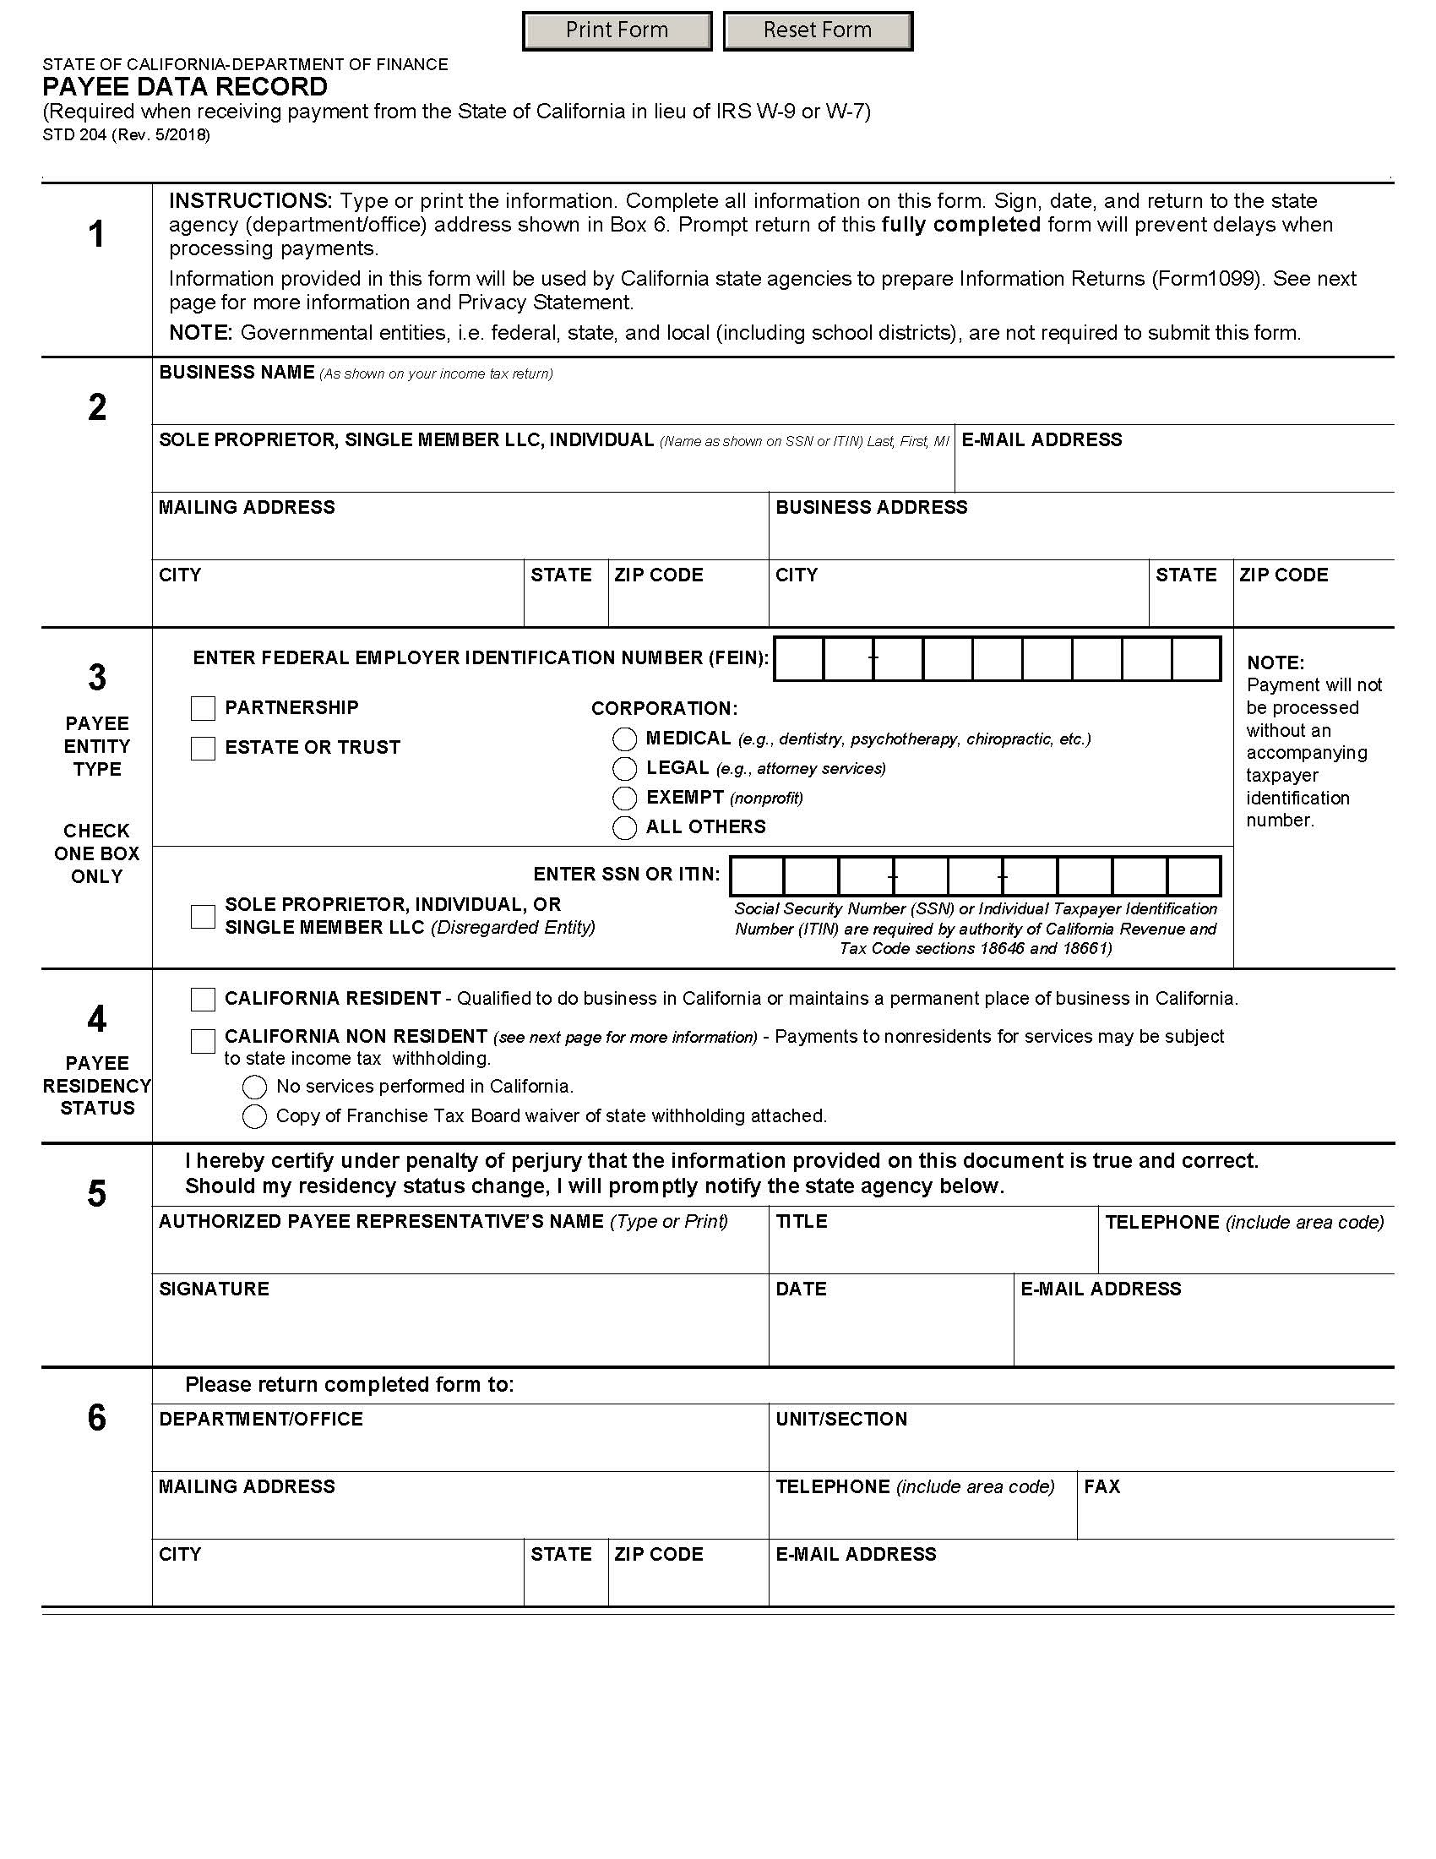
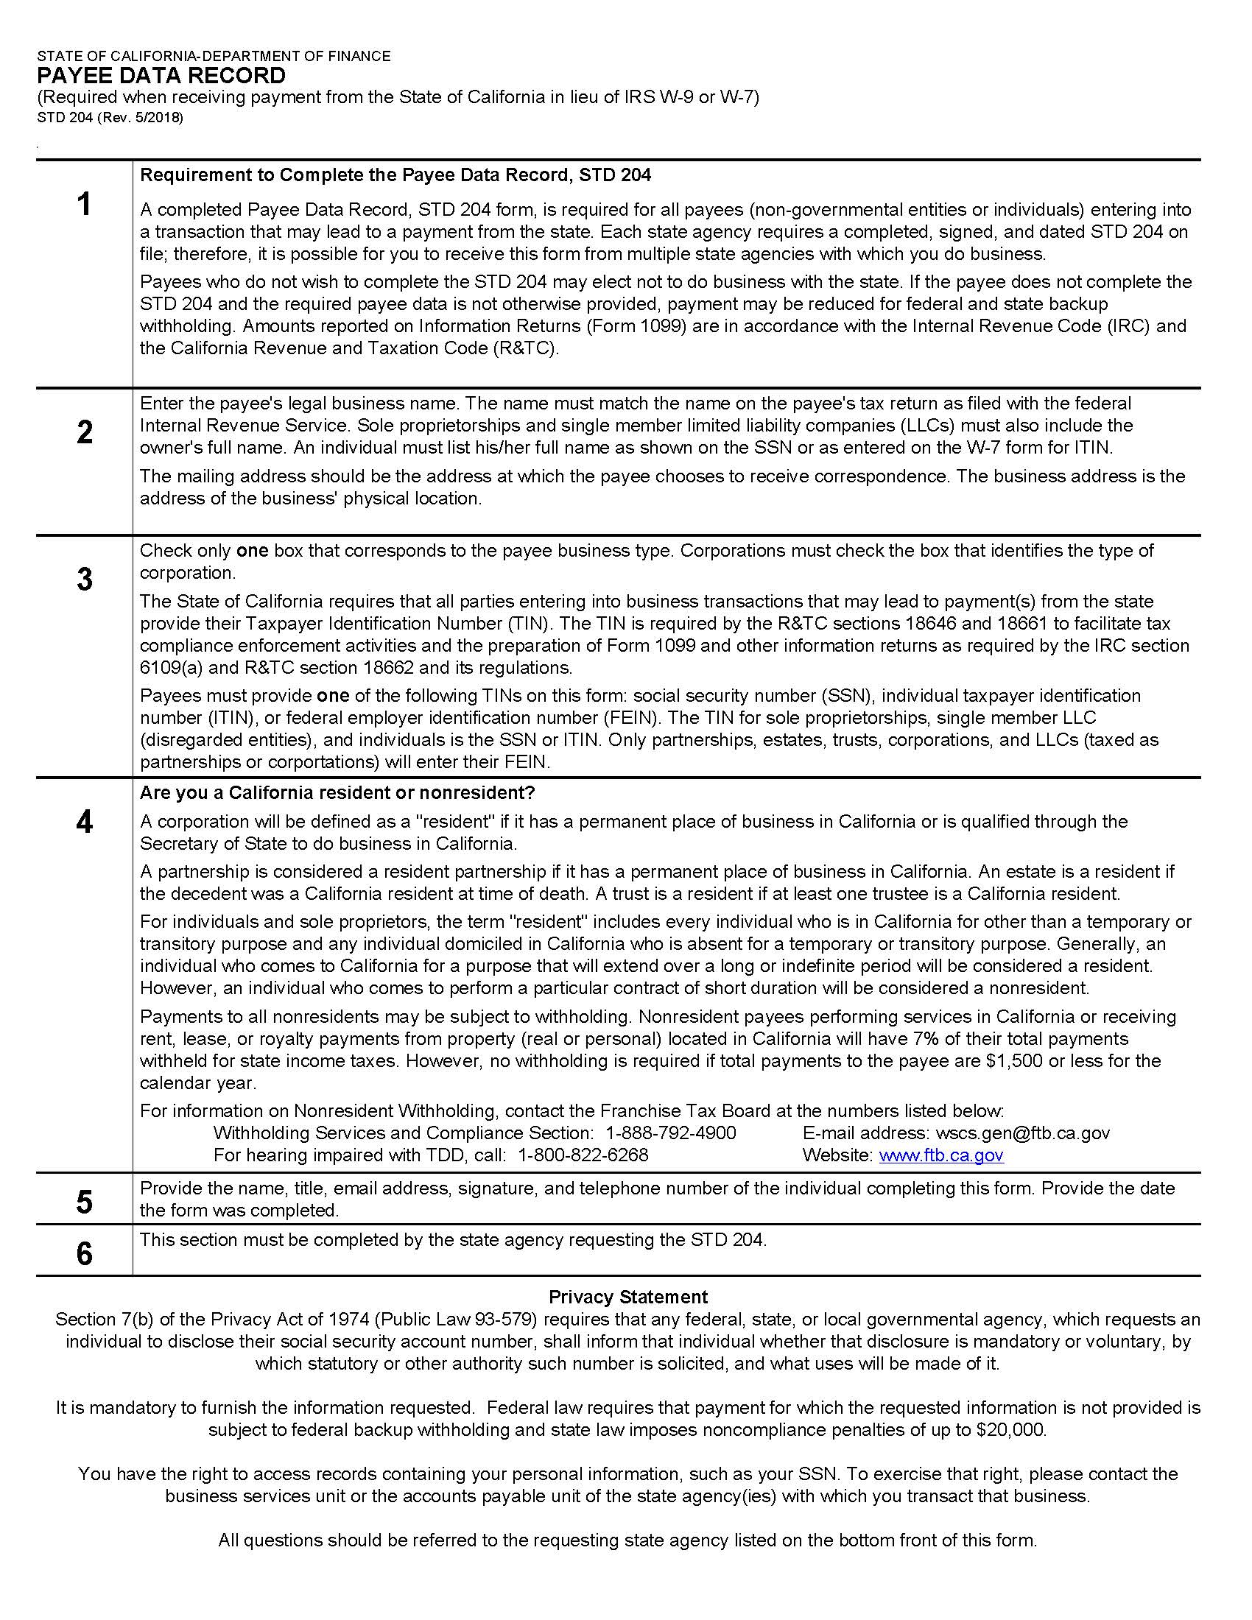

Attachment 8: Contractor Certification Clauses Form

View Contractor Certification Clauses Form

CERTIFICATION
I, the official named below, CERTIFY UNDER PENALTY OF PERJURY that I am duly authorized to legally bind the prospective Contractor to the clause(s) listed below. This certification is made under the laws of the State of California.
Contractor/Bidder Firm Name (Printed) |  | Federal ID Number
By (Authorized Signature)

Printed Name and Title of Person Signing

Date Executed | Executed in the County of

CONTRACTOR CERTIFICATION CLAUSES

1. STATEMENT OF COMPLIANCE: Contractor has, unless exempted, complied with the nondiscrimination program requirements. (Gov. Code §12990 (a-f) and CCR, Title 2, Section 11102) (Not applicable to public entities.)

2. DRUG-FREE WORKPLACE REQUIREMENTS: Contractor will comply with the requirements of the Drug-Free Workplace Act of 1990 and will provide a drug-free workplace by taking the following actions:

a. Publish a statement notifying employees that unlawful manufacture, distribution, dispensation, possession or use of a controlled substance is prohibited and specifying actions to be taken against employees for violations.

b. Establish a Drug-Free Awareness Program to inform employees about:

1) the dangers of drug abuse in the workplace;
2) the person's or organization's policy of maintaining a drug-free workplace;
3) any available counseling, rehabilitation and employee assistance programs; and,
4) penalties that may be imposed upon employees for drug abuse violations.

c. Every employee who works on the proposed Agreement will:
1) receive a copy of the company's drug-free workplace policy statement; and,
2) agree to abide by the terms of the company's statement as a condition of employment on the Agreement.

Failure to comply with these requirements may result in suspension of payments under the Agreement or termination of the Agreement or both and Contractor may be ineligible for award of any future State agreements if the department determines that any of the following has occurred: the Contractor has made false certification, or violated the certification by failing to carry out the requirements as noted above. (Gov. Code §8350 et seq.)

3. NATIONAL LABOR RELATIONS BOARD CERTIFICATION: Contractor certifies that no more than one (1) final unappealable finding of contempt of court by a Federal court has been issued against Contractor within the immediately preceding two-year period because of Contractor's failure to comply with an order of a Federal court, which orders Contractor to comply with an order of the National Labor Relations Board. (Pub. Contract Code §10296) (Not applicable to public entities.)

4. CONTRACTS FOR LEGAL SERVICES $50,000 OR MORE- PRO BONO REQUIREMENT: Contractor hereby certifies that Contractor will comply with the requirements of Section 6072 of the Business and Professions Code, effective January 1, 2003. Contractor agrees to make a good faith effort to provide a minimum number of hours of pro bono legal services during each year of the contract equal to the lessor of 30 multiplied by the number of full time attorneys in the firm’s offices in the State, with the number of hours prorated on an actual day basis for any contract period of less than a full year or 10% of its contract with the State. Failure to make a good faith effort may be cause for non-renewal of a state contract for legal services, and may be taken into account when determining the award of future contracts with the State for legal services.

5. EXPATRIATE CORPORATIONS: Contractor hereby declares that it is not an expatriate corporation or subsidiary of an expatriate corporation within the meaning of Public Contract Code Section 10286 and 10286.1, and is eligible to contract with the State of California.

6. SWEATFREE CODE OF CONDUCT:

a. All Contractors contracting for the procurement or laundering of apparel, garments or corresponding accessories, or the procurement of equipment, materials, or supplies, other than procurement related to a public works contract, declare under penalty of perjury that no apparel, garments or corresponding accessories, equipment, materials, or supplies furnished to the state pursuant to the contract have been laundered or produced in whole or in part by sweatshop labor, forced labor, convict labor, indentured labor under penal sanction, abusive forms of child labor or exploitation of children in sweatshop labor, or with the benefit of sweatshop labor, forced labor, convict labor, indentured labor under penal sanction, abusive forms of child labor or exploitation of children in sweatshop labor. The contractor further declares under penalty of perjury that they adhere to the Sweatfree Code of Conduct as set forth on the California Department of Industrial Relations website located at www.dir.ca.gov, and Public Contract Code Section 6108.

b. The contractor agrees to cooperate fully in providing reasonable access to the contractor’s records, documents, agents or employees, or premises if reasonably required by authorized officials of the contracting agency, the Department of Industrial Relations, or the Department of Justice to determine the contractor’s compliance with the requirements under paragraph (a).

7. DOMESTIC PARTNERS: For contracts of $100,000 or more, Contractor certifies that Contractor is in compliance with Public Contract Code section 10295.3.

8. GENDER IDENTITY: For contracts of $100,000 or more, Contractor certifies that Contractor is in compliance with Public Contract Code section 10295.35.

DOING BUSINESS WITH THE STATE OF CALIFORNIA

The following laws apply to persons or entities doing business with the State of California.

1. CONFLICT OF INTEREST: Contractor needs to be aware of the following provisions regarding current or former state employees. If Contractor has any questions on the status of any person rendering services or involved with the Agreement, the awarding agency must be contacted immediately for clarification.

Current State Employees (Pub. Contract Code §10410):

1). No officer or employee shall engage in any employment, activity or enterprise from which the officer or employee receives compensation or has a financial interest and which is sponsored or funded by any state agency, unless the employment, activity or enterprise is required as a condition of regular state employment.

2). No officer or employee shall contract on his or her own behalf as an independent contractor with any state agency to provide goods or services.

Former State Employees (Pub. Contract Code §10411):

1). For the two-year period from the date he or she left state employment, no former state officer or employee may enter into a contract in which he or she engaged in any of the negotiations, transactions, planning, arrangements or any part of the decision-making process relevant to the contract while employed in any capacity by any state agency.

2). For the 12-month period from the date he or she left state employment, no former state officer or employee may enter into a contract with any state agency if he or she was employed by that state agency in a policy-making position in the same general subject area as the proposed contract within the 12-month period prior to his or her leaving state service.

If Contractor violates any provisions of above paragraphs, such action by Contractor shall render this Agreement void. (Pub. Contract Code §10420)

Members of boards and commissions are exempt from this section if they do not receive payment other than payment of each meeting of the board or commission, payment for preparatory time and payment for per diem. (Pub. Contract Code §10430 (e))

2. LABOR CODE/WORKERS' COMPENSATION: Contractor needs to be aware of the provisions which require every employer to be insured against liability for Worker's Compensation or to undertake self-insurance in accordance with the provisions, and Contractor affirms to comply with such provisions before commencing the performance of the work of this Agreement. (Labor Code Section 3700)

3. AMERICANS WITH DISABILITIES ACT: Contractor assures the State that it complies with the Americans with Disabilities Act (ADA) of 1990, which prohibits discrimination on the basis of disability, as well as all applicable regulations and guidelines issued pursuant to the ADA.
(42 U.S.C. 12101 et seq.)

4. CONTRACTOR NAME CHANGE: An amendment is required to change the Contractor's name as listed on this Agreement. Upon receipt of legal documentation of the name change the State will process the amendment. Payment of invoices presented with a new name cannot be paid prior to approval of said amendment.

5. CORPORATE QUALIFICATIONS TO DO BUSINESS IN CALIFORNIA:

a. When agreements are to be performed in the state by corporations, the contracting agencies will be verifying that the contractor is currently qualified to do business in California in order to ensure that all obligations due to the state are fulfilled.

b. "Doing business" is defined in R&TC Section 23101 as actively engaging in any transaction for the purpose of financial or pecuniary gain or profit. Although there are some statutory exceptions to taxation, rarely will a corporate contractor performing within the state not be subject to the franchise tax.

c. Both domestic and foreign corporations (those incorporated outside of California) must be in good standing in order to be qualified to do business in California. Agencies will determine whether a corporation is in good standing by calling the Office of the Secretary of State.

6. RESOLUTION: A county, city, district, or other local public body must provide the State with a copy of a resolution, order, motion, or ordinance of the local governing body which by law has authority to enter into an agreement, authorizing execution of the agreement.

7. AIR OR WATER POLLUTION VIOLATION: Under the State laws, the Contractor shall not be: (1) in violation of any order or resolution not subject to review promulgated by the State Air Resources Board or an air pollution control district; (2) subject to cease and desist order not subject to review issued pursuant to Section 13301 of the Water Code for violation of waste discharge requirements or discharge prohibitions; or (3) finally determined to be in violation of provisions of federal law relating to air or water pollution.

8. PAYEE DATA RECORD FORM STD. 204: This form must be completed by all contractors that are not another state agency or other governmental entity.

